Barangay Flood Level Monitoring System

By:

Diaz, Don McLin D.

Padel, Junaina I.

Ballesteros, Kevin Jacob E.

Bato, Eriko M.

Olifernes, Eldon John T.

Dr. Leonard L. Alejandro

Professor

Table of Contents

Chapter No. Chapter Name Page No.

Abstract 3

1 **Barangay Flood Level Monitoring system**

Introduction 4

Purpose of the study 5

Scope and limitation 5

Objective 6

Significance of the Study 7

Definition of terms 8

2 **Barangay Flood Level Monitoring system**

Context Diagram 9

Review of Related Literature 10

Description of the system 13

Significance of the study 14

3 **Barangay Flood Level Monitoring system**

Methodology 15

System Requirements 16

Existing System 16

General Objectives 17

Specific Objectives 17

Scoop of the Existing System 17

Concept of Operation 18

Reference 19

**Abstract**

The Barangay Flood Monitoring System is a software application that is designed to monitor and track flood levels in a barangay in real-time. The system uses an IoT Ultrasonic sensor to collect data on water levels in rivers, streams, and other bodies of water in the barangay. This data is then transmitted to a central server, where it is analyzed and processed to provide accurate and up-to-date information on flood conditions.

The system is designed to help barangay officials and residents prepare for and respond to floods more effectively. By providing real-time information on flood levels, the system allows officials to issue timely warnings and take appropriate measures to protect the safety and well-being of residents. The system is also equipped with an alert system that manually sends notifications to residents if the water levels reach critical levels and allows residents to access information on flood conditions in their area, which can help them make informed decisions about their safety and property.

Chapter I

**Introduction**

In recent centuries, technology has had a huge impact on our daily lives because we have transportation, computers, buildings, etc., but this comes with negative effects on our environment, such as pollution, habitat destruction, and climate change.

Fossil fuels—coal, oil, and gas—are by far the largest contributors to global climate change, accounting for over 75 percent of global greenhouse gas emissions and nearly 90 percent of all carbon dioxide emissions  (*Burning of Fossil Fuels: Understanding Global Change*, 2022). We use this energy to generate electricity and to power transportation (for example, cars and planes) and industrial processes. Ever since the invention of the first coal-fired steam engines in the 1700s, our burning of fossil fuels has steadily increased. Across the globe each year, we now burn over 4,000 times the amount of fossil fuels burned in 1776. The effects of the burning of fossil fuels, especially carbon dioxide, are having far-reaching effects on our climate and ecosystems (United Nations, n.d.).

Global climate change has already had observable effects on the environment. Glaciers have shrunk, ice on rivers and lakes is breaking up earlier, plant and animal ranges have shifted, and trees are flowering sooner. Effects that scientists had predicted in the past would result from global climate change include loss of sea ice, accelerated sea level rise, and longer, more intense heat waves (*Climate Change—IM Power*, n.d.). Gradually shifting weather patterns and calamities with catastrophic effects have befallen us with increasing frequency due to climate change. The damages and losses to infrastructure, agriculture, and properties are huge. Tragically, lives were lost too. One of the ill effects of climate change is the abnormal volume of rain, which results in overflowing rivers and creeks; drainage systems overwhelm with the volume of water, flooding roads, creating gridlock, and causing damage to vehicles.

According to the Cabrera report (2022), modernizing the country’s flood forecasting and warning system should be a priority for the government, as the state weather bureau pointed out that floods continue to be one of the country’s biggest hazards.

Administrator Vicente Manalo of the Philippine Atmospheric Geophysical Astronomical Services Administration (PAGASA) said there are still plenty of improvements needed to fully equip the country’s flood forecasting and monitoring system to protect the public.

**Purpose of the study**

Climate change affects the world’s water in complex ways. From unpredictable rainfall patterns to shrinking ice sheets, rising sea levels, floods and droughts – most impacts of climate change come down to water (United Nations, n.d.). The project purpose is to provide accurate and real time data information about the state of flooding in the area, allowing authorities to respond quickly and effectively to protect the safety of residents and their properties.

The intended users are residents of the barangay and also barangay rescue team who handle the operation on typhoon disaster.

**Scope and limitation**

The Barangay Flood Level Monitoring System is an automated system designed to monitor water levels in flood-prone areas. It aims to provide early warning signals to the local government units and residents, allowing them to take necessary measures to minimize the impact of flooding.

The study will be conduct at the barangay Camansi Kabankalan, Negros Occidental since this place that the researchers aim for the research to took in place as well the information can be collected and accessible on the Barangay Hall.

The Barangay Camansi is still facing some problems collecting information of water level since the barangay is still developing. Some areas in barangay have the river that will rise when the storm surge comes. Residents can view a public barangay website for the flood information that contains real time data from sensor and alert message information that are uploaded by the barangay rescue team. Barangay rescue team has a security account in system when the account was login the very first page is a dashboard that contains of liquid display, line chart, and street list table form also barangay rescue team can access history report that contains of history data from sensor, sensor post display mapping, and resident contact information with sensor name data near there area.

The system consists of sensors placed in critical points, such as rivers, creeks, and other bodies of water in the barangay. The system used an arduino, ultrasonic sensor and ethernet shield that can transmit data to a central server for processing and analysis.

Moreover, the system can generate reports and analysis that can be used for flood risk assessment and management. This information can be used by barangay officials to plan and implement flood prevention and mitigation measures in the barangay.

**System Features**

* Real-time monitoring of water levels
* Flood modeling and sensor post mapping
* Generate alerts and notifications to barangay officials and residents through SMS, and barangay website.
* Generate sensor data history report.

This feature can help them make informed decisions and take necessary actions to prevent flooding or mitigate its effects.

**System Limitations**

The system doesn’t support global mapping such as the use of government satellites “Diwata 1”. In addition, the system cannot generate global news reports from media coverage. The barangay rescuers need to evaluate the monitored sensor in advance analysis by their own decision making. The SMS system is not automated; this must be done by manually sending alert message to all residents.

**Objective**

The objective of the study is to provide accurate and real-time information on water levels in flood-prone areas to help local government units and residents take necessary measures to prevent or minimize the impact of flooding.

**Specific Objectives**

*Specifically, it aims to.*

1. To design the monitoring system with the following features or capabilities
   * Dashboard
   * History record report
   * To track water level
   * Add new resident contact info
   * Add new sensor post
   * Add notification alert message
2. To install sensors in critical points such as rivers, creeks, and other bodies of water in the barangay for accurate water level monitoring.
3. To develop a communication system that can transmit data from the sensors to a central server for processing and analysis.
4. To provide real-time monitoring of water levels and weather forecasting for early warning signals and informed decision-making.
5. To generate alerts and notifications to barangay officials and residents through SMS, and barangay website.
6. To generate reports and analysis that can be used for flood risk assessment and management.

**Significance of the studies**

It aims to address the increasing problem of flooding in flood-prone areas. By providing accurate and real-time information on water levels, this system can help local government units and residents take necessary measures to prevent or minimize the impact of flooding.

The installation of sensors in critical points such as rivers, creeks, and other bodies of water in the barangay ensures accurate monitoring of water levels. The development of a communication system that can transmit data from the sensors to a central server for processing and analysis ensures that the information gathered is processed quickly and efficiently.

Real-time monitoring of water levels and weather forecasting provided by the system can help local government units and residents make informed decisions regarding evacuation or other necessary actions. Alerts and notifications generated by the system can reach barangay officials and residents through various communication channels, ensuring that they receive timely information about the flooding situation.

The generation of reports and analysis that can be used for flood risk assessment and management is also significant. This information can help local government units plan and implement flood prevention and mitigation measures in the barangay.

**Definition of terms**

BFLMS - Barangay Flood Level Monitoring System.

Monitoring System - to track, measure, and report data received from Ultrasonic sensors.

History Record Report - sensor data record with date and time in table format.

Fossil fuel - is a fuel made of century old dead bodies of plants and animals that were used in the 1700s that caused pollution over the years.

Climate change - is a weather condition that gradually changes patterns that cause more catastrophic effects globally.

Arduino - is a main hardware device used in projects.

Ultrasonic sensor - is a hardware module device that gathers record data of water level.

Communication system - is a connection of an arduino device to the central server used by RJ45.

Storm surge - is abnormally rising of water level.

PAGASA - Philippine Atmospheric Geophysical Astronomical Services Administration.

Diwata 1 - Philippine government satellite.

Chapter II

**Review Of Related Literature and Studies**

**Context Diagram**

Barangay Flood Level Monitoring System alerts the resident nearby the flood prone area through SMS and website where resident can access freely. An Arduino Uno Microcontroller is used to collect sensor data and store it on the MySql database server. It is interface with Ultrasonic sensor and 10/100Mbps Ethernet Shield (ENC28J60). The sensor generates an output voltage proportional to the resistance; by measuring this voltage, the water level can be determined. The calculated water level is update to the webpage. The water level calculated would then be compared with the set threshold.

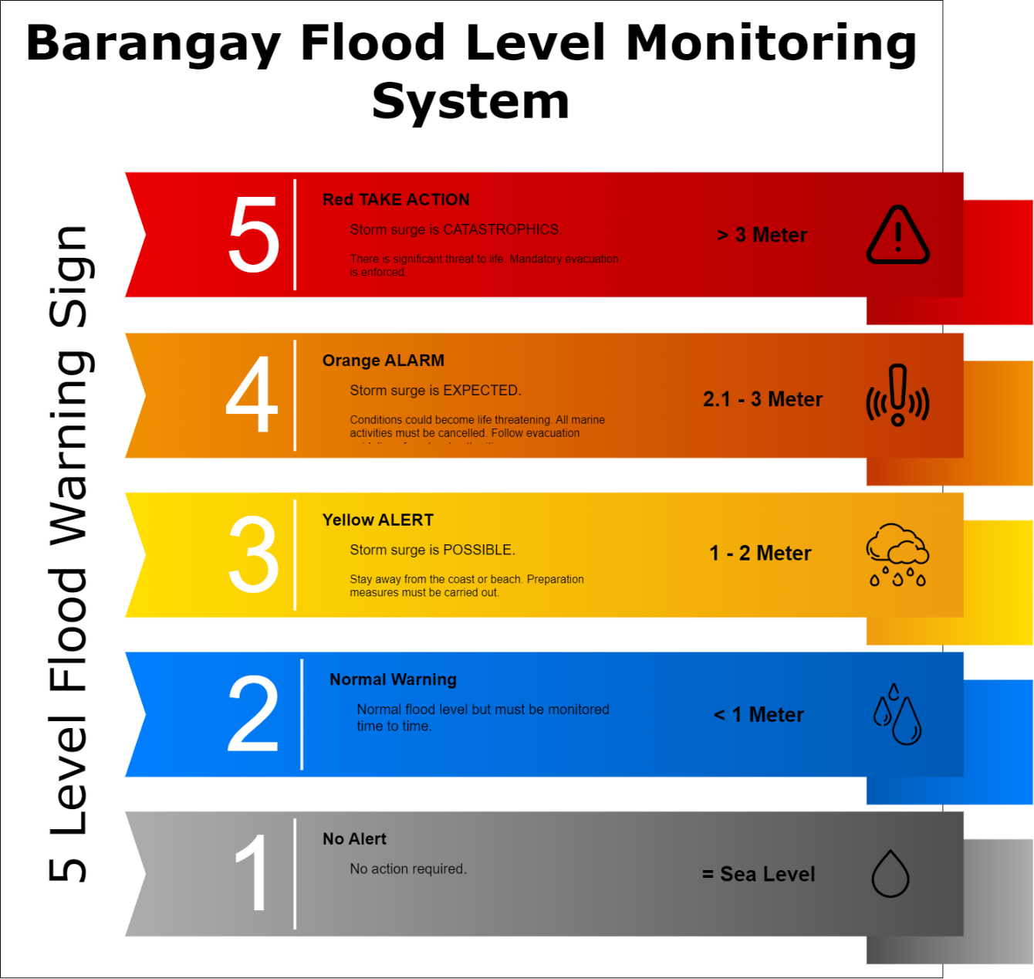

*Figure 1. Five Level Flood Warning Signs.*

Figure 1 shows the system's five levels of warning signs, which consist of:

1. No Alert (Gray). No action required. Water equals to sea level.
2. Normal Warning (Green). Normal flood level but must be monitored time to time. Under 1 meter above sea level.
3. ALERT (Yellow). Storm surge is POSSIBLE. Stay away from the coast or beach. Preparation measures must be carried out. 1 to 2 meter above the sea level.
4. ALARM (Orange). Storm surge is EXPECTED. The condition must life threatening. All marine activities must be cancelled. Follow evacuation guidelines from local authorities. 2.1 to 3 meter above the sea level.
5. TAKE ACTION (Red). Storm surge is CATASTROPHICS. There is significant threat to life. Mandatory evacuation is enforced. Over 3 meter above sea level.

If the current level is higher than the set threshold value, the microcontroller would warn the user that the sensor level has reached the indicated warning level.

**Proposed DFD**

The context diagram of barangay flood monitoring system represents the flow of data throughout the system. It shows what information could be input, where the data goes, and how it is stored.

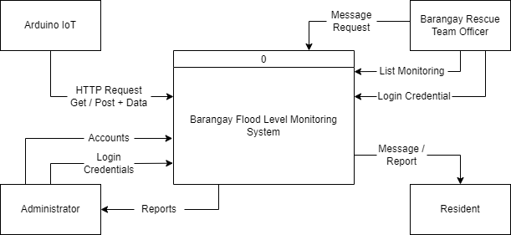

*Figure 2. Context Diagram.*

Figure 2 shows the four entities such us Arduino IoT, Administrator, Barangay Rescue Team Officer’s, and Resident.

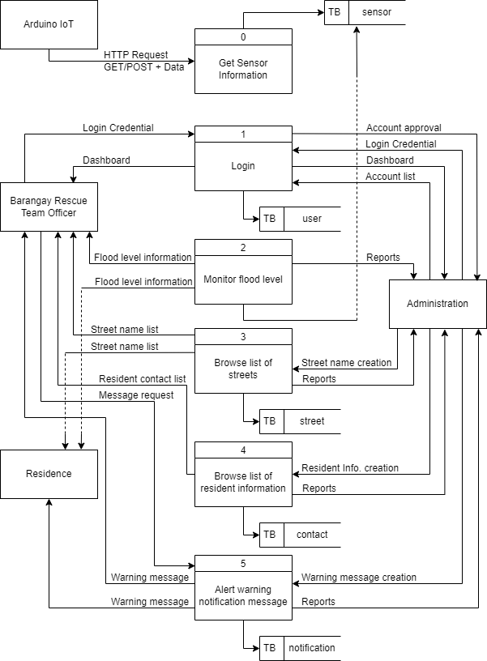

*Figure 3. Level 0 Diagram.*

Figure 3 shows the entire system data flow of barangay flood level monitoring system. It’s explained the flow from every side of entities;

1. Arduino IoT entity shows how data flow input automatically the data to the database.
2. Barangay Rescue Team Officer entity shows the login process that need to enter correct combination of username and password to access the limited features of the system.
3. Administrator entity shows the login process that need to enter correct combination of username and password to access the full features of the system that manage the input information data that needed to monitored and change upon the strategy of the barangay.
4. Resident entity shows the data flow that displays the list of features the Resident can access. The resident can view the display information such as monitoring flood level, list of streets, and can receive SMS message.

**Existing DFD**

According to the studies of Zahir et al., n.d. (2019) Based on flowchart in Figure 4 below, Smart IoT Flood Monitoring System is developed to alert the public closest to the area when there is upcoming flood. The process is starting when ultrasonic sensor measures level of water in the river. The collected data from the sensor are gathered and will be forwarded to microcontroller and data will be displayed at web server. Then, data will be analyzed and compared. Asa user, he/she can control the stepper motor and buzzer wirelessly. Flood status dangerous will be determined based on that collected data. Thus, water level status will display on LCD and web server. LED will be turn on to indicate the water level. Furthermore, the stepper motor will be turn on for the passage of excessive flood when it reached at the highest threshold value and the alarm will be triggered immediately to alert the public. Hence, the citizens will be well prepared for evacuation before the flood occurred.

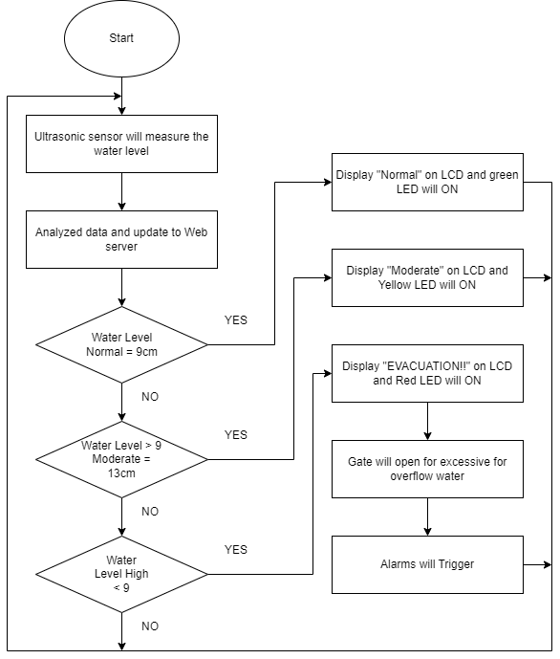

*Figure 4. Flowchart of the System (Existing DFD).*

**Review of Related Literature**

In this chapter presents and discusses foreign and local literature and studies that are related to barangay flood level monitoring systems, an important tool in ensuring the safety and well-being of people living in flood-prone areas. There have been several studies and works of literature related to the development and implementation of such systems. These studies showed the importance of flood monitoring systems in disaster risk reduction and management in barangays. The proposed systems can provide real-time information, early warning alerts, and cost-effective solutions to the problem of flooding in communities.

**Foreign Literature**

A study conducted by Choi et al. (2016) in Korea developed a flood forecasting and warning system for urban areas using remote sensing and GIS technologies. The system provides real-time information on flood levels and predicts flood inundation areas. The study showed that the proposed system can effectively reduce the damage caused by floods.

A study by Li et al. (2017) in China developed a flood warning system using wireless sensor networks (WSNs) and cloud computing technologies. The system can monitor water levels and provide early warning alerts to the public through a mobile application. The study showed that the system can effectively reduce the response time to floods and enhance the public's ability to respond to emergencies.

These studies show that barangay flood monitoring systems are being developed and implemented in various parts of the world. The systems use various technologies such as remote sensing, wireless sensor networks, machine learning, and satellite imagery to monitor floods and provide early warning alerts. These systems can effectively reduce the damage caused by floods and enhance the public's ability to respond to emergencies.

**Local literature**

According to Jibiki, Y., Kure, S., Kuri, M., & Ono, Y. (2016) The previous literature indicates that one major problem with the early warning system in Typhoon Haiyan was that local residents did not understand the meaning of the term “storm surge”. Furthermore, even though they were aware of the Philippines weather authority (PAGASA) warning, they underestimated the severity of the typhoon and did not evacuate in a timely manner. This study aimed to provide a quantitative analysis of this phenomenon. The authors demonstrated that it cannot be concluded that misunderstanding the term “storm surge” directly led to underestimation and failure to evacuate, although a high level of underestimation among respondents was observed. The fact that those who did not underestimate the severity of the typhoon were more likely to evacuate their houses indicates that accurate warning messages were not “personalized” for local residents.

The Global Initiative on Disaster Risk Management (2018) said that The Deutsche Gesellschaft für Internationale Zusammenarbeit (GIZ) GmbH has developed an integrated approach for Local Flood Early Warning Systems (LFEWS) in the Philippines. LFEWS combine the capacities of the national meteorological authority, local government units and the communities. The approach focuses on small to medium-sized river basins and is tailored to local conditions. Where necessary, the system may be supplemented with GIS data and satellite information. Data on the extent and frequency of rising water levels provide important information for risk maps that can be used to prepare or adapt land-use plans.

**Foreign Studies**

According to the studies of S. Jana Priya, S. Akshaya, E. Aruna, J. Arokiya Mary Julie and V. Ranjani (2017) Flood is one of the natural disasters which cannot be avoided totally. Every year, death rate due to flood increases because of absence of early warning. To solve this problem, this paper demonstrates the idea and implementation of a Flood Monitoring and Alerting system using Internet of Things (IOT) technology. This system comprises of three parts. The first part measures the height of the water using ultrasonic distance measuring sensor. The second part is sending the height information to web page using the Ethernet shield. The third part is making call to residences to alert them about flood through voice message. The call is made through the most popular mobile standard Global System for Mobile Communication (GSM) and ARP33A3 is used to play the recorded voice message.

The Internet of Things builds on three major technology layers: Hardware (including chips and sensors), Communication (including mostly some form of wireless network), and Software (including data storage, analytics, and front-end applications). IoT describes a system where items in the physical world, and sensors within or attached to these items, are connected to the Internet via wireless and wired Internet connections. The physical objects that are being connected will possess one or more sensors. Each sensor will monitor a specific condition such as location, vibration, motion and temperature. In IoT, these sensors will connect to each other and to systems that can understand or present information from the sensor’s data feeds. These sensors will provide new information to a company’s systems and to people.

**Local Studies**

According to the studies of Joy J. Labo et al. (2016) Community-based early warning systems (CBEWS) is a “people-centered” system and empowers individuals and communities threatened by hazards to act on sufficient time and in an appropriate manner to reduce the possibility of personal injury, loss of life, damage to property, environment and loss of livelihood. These things lead to the development of the device necessary for the protection of the community against flood hazards as it allows people to get prepared with sufficient time. An alarm system was developed to monitor the water level on Salog River that overflows during heavy rains. The water level sensors were submerged in a canal of water to test the functionality of the device before its installation. Computer programs were created to enhance the monitoring of water level: the River Monitor Software and the Water Level Monitor. The LED arrays emit light according to water level; green for low, orange for medium, and red for high. A siren also alarms with different intervals (30 seconds for low, 15 seconds for medium, and a continuous alarm for high). Automatic emergency lighting was integrated in the design and lights up during power outages powered by rechargeable sealed battery that charges when ac power is supplied to the device. Levels were established based on available data; low water level means awareness; medium water level means preparedness and high-water level means immediate response is necessary.

**Description Of the Study**

The Barangay Flood Level Monitoring system is a system designed to monitor and predict flood levels in a specific barangay or community. The system is typically composed of sensors, data collection devices, and software that enable local authorities to monitor water levels in rivers, creeks, and other waterways that are prone to flooding. The system works by continuously monitoring water levels and transmitting data in real-time to a central database. This data is then analyzed and processed to predict the likelihood and severity of flooding in the area. The system may also incorporate weather forecasts and historical data to improve its predictions. The Barangay Flood Level Monitoring system is a system designed to monitor and predict flood levels in a specific barangay or community. The system is typically composed of sensors, data collection devices, and software that enable local authorities to monitor water levels in rivers, creeks, and other waterways that are prone to flooding. The system works by continuously monitoring water levels and transmitting data in real-time to a central database. This data is then analyzed and processed to predict the likelihood and severity of flooding in the area. The system may also incorporate weather forecasts and historical data to improve its predictions. Local authorities can use this information to issue early warnings to residents and take appropriate measures to prevent or mitigate the effects of flooding. This could include evacuating vulnerable populations, securing critical infrastructure, and pre-positioning emergency supplies. The Barangay Flood Level Monitoring system can be an effective tool for disaster risk reduction and management, as it enables authorities to make informed decisions and take early action to protect their communities from the devastating effects of floods.

**Significance of the system**

The Barangay Flood Level Monitoring system is significant in several ways. First, it can help in disaster risk reduction and management by providing real-time information on flood levels and early warning alerts to the barangay officials and residents. This can help in reducing the risk of loss of life and property damage due to floods. Second, the system can aid in decision-making for disaster response and management. With accurate and timely information on flood levels, barangay officials can make informed decisions on evacuation, relief operations, and other necessary measures to protect their constituents. the system can help in mitigating the impact of floods on the community. By monitoring flood levels and providing early warning alerts, residents can take necessary precautions to minimize the damage to their homes and properties. Fourth, the system can contribute to the development of a more resilient community. With a Barangay Flood Level Monitoring system in place, barangays can better prepare for and respond to natural disasters, leading to a more resilient community that can recover quickly from disasters.

Chapter III

**Methodology**

Barangay flood level monitoring system is created in compliance of agile model. The Agile methodology is a way to manage a project by breaking it up into several phases.

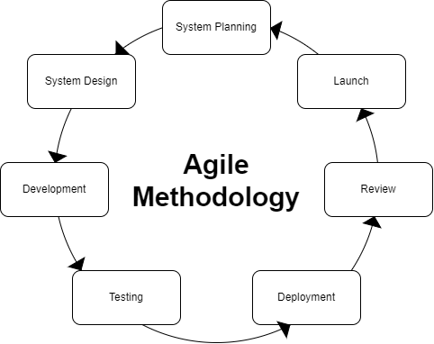

*Figure 5. Agile Methodology*

Figure 5. shows the model where Barangay flood level monitoring system was based upon.

**System planning phase** – at this phase involves identifying, analyzing, and defining the scope of the barangay flood level monitoring system, as well as assessing the feasibility and potential risks on developing the barangay flood level monitoring system.

**System design** – in this phase identifies the system hardware and system requirements.

**Development phase** – in this phase the actual software or system is built.

**Testing phase** – in this phase the software developed unit and its parts are tested.

**Deployment phase** – in this phase the technical and functional specifications are transformed into a working system or software product.

**Reviewing phase** – in this phase the system has been review to ensure that it meets the business objectives outlined, and evaluating the overall success of the project.

**Launching phase** – after the aforementioned phases and the final testing the system or software product is launched or released to the end-users.

**User Story Mapping**

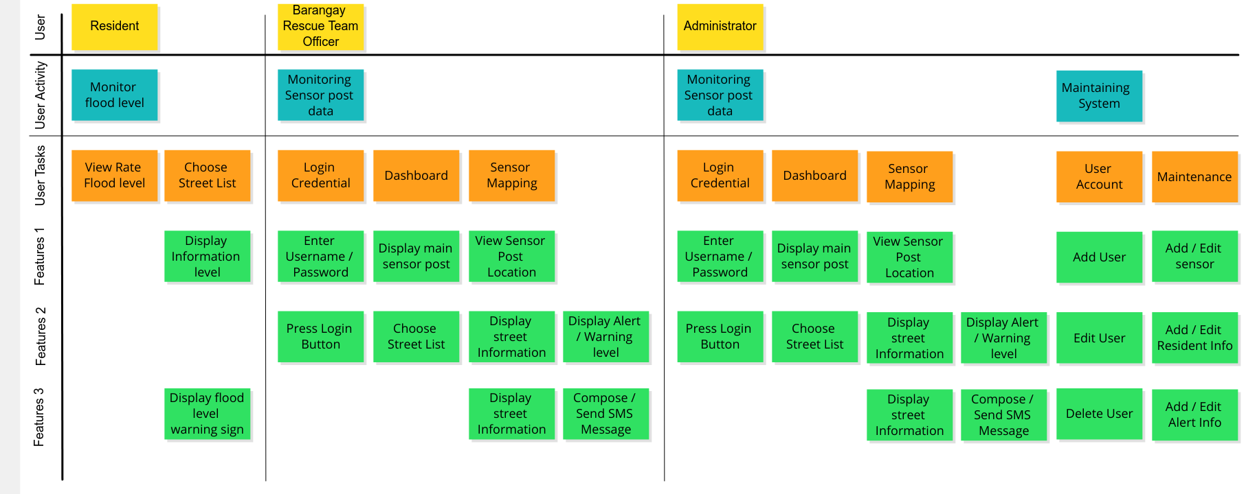

*Figure 6. Barangay Flood Level Monitoring System User Story Mapping.*

Figure 6 shows the barangay flood level monitoring system user story map

**System Requirements**

System Features

* Liquid meter level
* Realtime monitoring line chart
* Notification flood warning alert
* Resident Contact info
* Color coding flood warning signs

Hardware Specification

* 11th Gen Intel(R) Core(TM) i5-11400H @ 2.70GHz 2.69 GHz
* 8.00 GB (7.78 GB usable) Ram
* Main Storage 500gb M.2 nvme
* Second Storage 1Tb M.2 nvme
* UNO R3 Board compatible with Arduino
* Ultrasonic sensor
* Ethernet Shield (ENC28J60)

Software Specification

* Windows 11 ver. 22H2
* VSCode ver. 1.76.2
* Arduino IDE 2.0.4, and Xampp

Network Specification

* RJ45
* UTP Cable Cat5e

**The Existing System**

The flood monitoring systems are done with the traditional, manually operated paint meter system. Traditional flood monitoring systems are often simple and cost-effective, but the system relies on human observation and may not provide accurate, real-time data on flood levels. This will delay the response team. The data may be manually observed and recorded by video, but this will be time-consuming since the traditional manual paint system needs to be done by observation and manual recordings.

**General Objectives**

This Study means to ensure the availability of sufficient information and safety for the community within the Barangay.

**Specific Objectives**

* To record real-time flood water level.
* To ensure the availability of sufficient information for the resident of the barangay.
* Developing a prototype flood level system to track and monitor the risk of incoming flood.

**Scope of the Existing System**

The existing flood monitoring system has different features such as a geographic information system (GIS) to map flood-prone areas, a mobile app for residents to report flooding incidents, and the Internet of Things, all of which are possible additions to the current Flood Level Monitoring System. The Internet of Things is based on three major technological pillars: hardware (including chips and sensors), communication (mostly through wireless networks), and software (including data storage, analytics, and front-end applications). IoT refers to a system in which physical objects and the sensors found inside or attached to them are linked to the Internet through both wireless and cable connections. There will be one or more sensors on the linked physical items. Each sensor will keep an eye on a certain factor, such as temperature, vibration, motion, and position. These sensors will be interconnected as part of the IoT with systems that can comprehend or display information from the data feeds of the sensors. The systems and employees of a corporation will both get fresh information from these sensors. Monitoring local rivers, streams, and other bodies of water for possible flooding Real-time weather reporting on factors like rainfall and storms that may cause floods Issuing flood warnings and notifications to local communities, including details on flood extent, depth, and potential effects.

**Concept of Operation**

**Data Collection** - The system would collect real-time data on water levels, and other relevant information from sensors, gauges, and other sources located throughout the Barangay.

**Data Processing** - The collected data would be processed and analyzed to identify potential flood risks, assess the severity of flood events, and determine appropriate responses.

**Flood Warning and Alert** - The system would issue flood warnings and alerts to the Barangay officials and residents through various communication channels, such as text messages, website update notification, or loudspeakers. The warnings would provide information on the extent and severity of the flood, potential impact on the Barangay, and recommended actions to take.

**Response Coordination** - The Barangay officials would coordinate with government agencies, such as disaster response and management units, to mobilize resources and respond to the flood event. The system would facilitate communication and coordination among various stakeholders involved in flood response and recovery efforts.

**Flood Risk Mitigation** - The system would identify areas of the Barangay that are most vulnerable to flooding and prioritize measures to mitigate flood risks, such as building flood walls, dredging waterways, or relocating residents from high-risk areas.

**System Maintenance and Upgrades** - The system would undergo regular maintenance and upgrades to ensure its accuracy and reliability. This would include calibration of sensors and gauges, testing of communication channels, and software updates to improve the system's performance and functionality.

**Reference:**

United Nations. (n.d.). *Causes and Effects of Climate Change | United Nations*.

https://www.un.org/en/climatechange/science/causes-effects-climate-change

“Burning of fossil fuels - Understanding Global Change.” *Understanding Global Change*, 8 March 2022, https://ugc.berkeley.edu/background-content/burning-of-fossil-fuels/?fbclid=IwAR0l7VWTG13kQ3Xt7KvDR5SBKIxmUOlJaGEv6439Y81dJzeOSC51Igw26A8.

*Climate Change – IM Power*. (n.d.).

https://www.impowerplc.com/climate-change/

Cabrera, Romina. *PAGASA: Flood warning system must be prioritized*, The Philippine Star, 24 July 2022, https://www.philstar.com/headlines/2022/07/24/2197581/pagasa-flood-warning-system-must-be-prioritized.

United Nations. “Water – at the center of the climate crisis | United Nations.” United Nations, https://www.un.org/en/climatechange/science/climate-issues/water?gclid=Cj0KCQjw2v-gBhC1ARIsAOQdKY0w3lqddumslGOExEnsuuAVzv5dw0az53lVcUXJp-XnnRahE5GG558aAi5IEALw_wcB.

<https://www.ijera.com/papers/Vol6_issue1/Part%20-%206/H61065764.pdf>

<https://arduinogetstarted.com/tutorials/arduino-mysql>

Local Flood Early Warning Systems in the Philippines | The Global Initiative on Disaster Risk Management. (n.d.). Local Flood Early Warning Systems in the Philippines | the Global Initiative on Disaster Risk Management. <https://www.gidrm.net/en/products/local-flood-early-warning-systems>

Jibiki, Y., Kure, S., Kuri, M., & Ono, Y. (2016). Analysis of early warning systems: The case of super-typhoon haiyan. International Journal of Disaster Risk Reduction, 15, 24–28. [https://doi.org/10.1016/j.ijdrr.201 5.12.002](https://doi.org/10.1016/j.ijdrr.201%205.12.002)

Joy J. Labo et al. Int. Journal of Engineering Research and Applications www.ijera.com ISSN: 2248-9622, Vol. 6, Issue 1, (Part - 6) January 2016, pp.57-64

S. Jana Priya, S. Akshaya, E. Aruna, J. Arokiya Mary Julie andV. Ranjani, Flood Monitoring and Alerting System.

*International Journal ofComputer Engineering & Technology*

, 8(2), 2017, pp. 01 05.http://www.iaeme.com/IJCET/issues.asp?JType=IJCET&VType=8&IType=2

https://www.wrike.com/project-management-guide/faq/what-is-agile-methodology-in-project-management/

S. Jana Priya, S. Akshaya, E. Aruna, J. Arokiya Mary Julie andV. Ranjani, Flood Monitoring and Alerting System. International Journal ofComputer Engineering & Technology, 8(2), 2017, pp. 01–05.http://www.iaeme.com/IJCET/issues.asp?JType=IJCET&VType=8&IType=2

Zahir, Shahirah Binti et al. “Smart IoT Flood Monitoring System.” Journal of Physics: Conference Series 1339.1 (2019): 012043. Web.